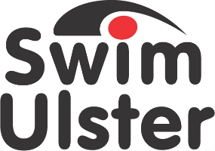

Nomination Form for
Club Volunteer of the Year Awards

CLOSING DATE FRIDAY 18th OCTOBER 2019

Nominee
Name

Club

Email
Number of years volunteering

Achievements
Details of volunteering in 2018/2019 season

Dedication
Give details of the nominees dedication to the club and their contribution to the sport of swimming

.
Additional Supporting Information

Declaration
I hereby nominate ___________________________________
For Volunteer of the year Award.
I confirm the details given in support of this nomination are accurate.

Signed ___________________________________
Position ___________________________________
Club ___________________________________

PLEASE SEND TO;
Ruth McQuillan
ruth@swimulster.net

or post to

Ruth McQuillan
Swim Ulster
Aurora Aquatic & Leisure Complex
3 Valentine Rd
Bangor
BT20 4TH

