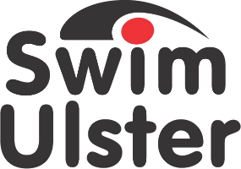

Nomination Form for
Swim Ulster Club Coach of the Year Awards

CLOSING DATE FRIDAY 18th OCTOBER 2019
Nominee
Name

Club

Email
Coaching Qualifications (minimum level 2)
License Number
Current coaching role

Number of years coaching

Level of athletes coached

Achievements
What have been the nominee’s greatest achievements during the 2018/19 season?

Impact
How has this coach made a positive impact on the club during the 2018/19 season?

Dedication

Number of hours coaching per week

Continuing Personal Development
Please provide evidence of how the nominee has developed his or her skills as a coach and kept up to date. This could be by their attitude and commitment to CPD through e-learning and webinars, attending workshops, working with fellow coaches or other ways

Additional Supporting Information

Declaration
I hereby nominate ___________________________________
For Club Coach of the year Award.
I confirm the details given in support of this nomination are accurate.

Signed ___________________________________
Position ___________________________________
Club ___________________________________

PLEASE SEND TO;
Ruth McQuillan
ruth@swimulster.net

or post to

Ruth McQuillan
Swim Ulster
Aurora Aquatic & Leisure Complex
3 Valentine Rd
Bangor
BT20 4TH

