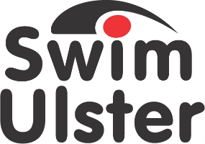

Nomination Form for
Swim Ulster Teacher / Junior Development Coach of the Year Awards

CLOSING DATE FRIDAY 18th OCTOBER 2019
Nominee
Name

Club

Email
Coaching / Teaching Qualifications
License Number
Current coaching role

Number of years coaching

Level of athletes coached

Achievements
What have been the nominee’s greatest achievements during the 2018/19 season?

Impact
How has this coach made a positive impact on the club during the 2018/19 season?

Dedication

Number of hours coaching per week

Continuing Personal Development
Please provide evidence of how the nominee has developed his or her skills as a coach and kept up to date. This could be by their attitude and commitment to CPD through e-learning and webinars, attending workshops, working with fellow coaches or other ways

Additional Supporting Information

Declaration
I hereby nominate ___________________________________
For Club Coach of the year Award.
I confirm the details given in support of this nomination are accurate.

Signed ___________________________________
Position ___________________________________
Club ___________________________________

PLEASE SEND TO;
Ruth McQuillan
ruth@swimulster.net

or post to

Ruth McQuillan
Swim Ulster
Aurora Aquatic & Leisure Complex
3 Valentine Rd
Bangor
BT20 4TH

